Thinking about the way you organize your contacts in a new phone is an example of which analytical skill?



Data strategy



Data design



Curiosity



Understanding context

**Correct**

This is an example of data design, which involves how information is organized.

You are planning a road trip. Your first step is to break down the planning into smaller pieces. You begin by calculating your budget. Then, you choose a destination and departure date. Next, you plan where to stay, what vehicle to take, and how long you want to be on the road. Which analytical skill does this scenario describe?



Data design



Understanding context



Having a technical mindset



Curiosity

**Correct**

This scenario describes having a technical mindset. A technical mindset is the ability to break things down into smaller steps or pieces and work with them in an orderly and logical way.

**1.**

Question 1

This practice quiz will help you get a read on the analytical skills you already have.

After you respond to each question, be sure to check the feedback you receive. This will help you check your own thinking against the expected thinking for these questions. The analytical skills assessed in this quiz will come in handy and be further developed as you progress in the program.

---

Identify the pattern from left to right in the set of blocks below and try to predict which block should replace the block with the question mark.

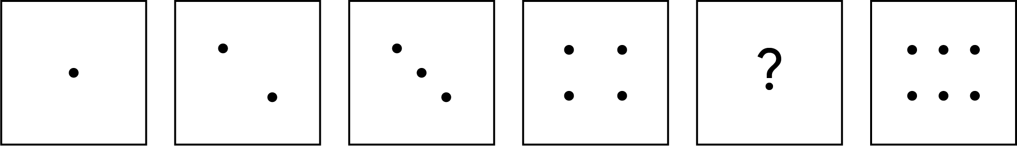

**1 / 1 point**











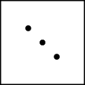





**Correct**

This is the missing block. The pattern of the dots increases by one in each block. Therefore, the best answer has five dots.

**2.**

Question 2

Here's a more complex pattern. Identify the pattern from left to right in the images below and try to predict which image should come next.

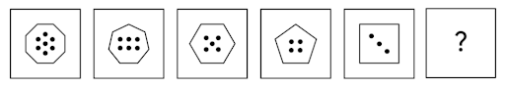1st pattern: Octagon with 7 dots 2nd pattern: Heptagon with 6 dots 3rd pattern: Hexagon with 5 dots 4th pattern: Pentagon with 4 dots 5th pattern: Square with 3 dots 6th pattern: Question mark

Based on the images above, which option comes next in the pattern?

**1 / 1 point**



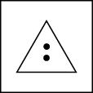







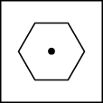



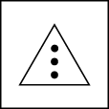

**Correct**

This is the next image in the sequence based on two patterns present in the series: the number of sides and the number of dots. Moving from left to right, both decrease by one. Given these patterns, if the previous block contained a shape with four sides and three dots, then the next shape should have three sides and two dots.

**3.**

Question 3

Now, find a pattern in a different format. Select the next number in the sequence:

Fill in the blank: 9, 13, 17, 21, 25, 29, _____

**1 / 1 point**



10



33



55



25

**Correct**

The correct answer is 33. The pattern of numbers are all increasing, and the difference between each number is 4.

**4.**

Question 4

The following numbers are in a sequence from left to right. Determine the pattern and decide which number should come next:

Fill in the blank: 4, 9, 16, 25, 36, 49, _____

**1 / 1 point**



64



81



30



62

**Correct**

The next number in the series is 64. There are two patterns in the sequence. One is that each number is squared and then the number being squared is increased by one (e.g., 2², 3², 4², 5², 6², 7²). The second pattern is in the difference between the numbers in the sequence: 9 - 4 = 5, 16 - 9 = 7, 25 - 16 = 9, and so on.

**5.**

Question 5

The following question is about recognizing and matching patterns in shapes that are the same, but viewed from different angles.

Two shapes are similar when one can become the other after a rotation clockwise ⟳ or counterclockwise ↺, or a reflection horizontally ↔ and/or vertically ↕.

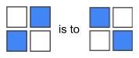

Your task is to choose the figure that completes the statement. Pay attention to the pattern by which the first and second shapes are related, and then figure out which choice matches shape 3. Fill in the blank:

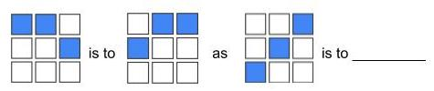

Select the image below that completes the statement.

**1 / 1 point**



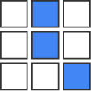



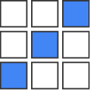



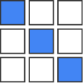



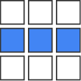

**Correct**

This image completes the statement. The first image in the statement is reflected in the second image. To complete the analogy, the answer would be an image that is a side-by-side reflection of the third image.

**6.**

Question 6

The following question is about recognizing and matching patterns in shapes that are the same, but viewed from different angles. Two shapes are similar when one can become the other after a rotation clockwise ⟳ or counterclockwise ↺, or a reflection horizontally ↔ and/or vertically ↕.

Your task is to choose the figure that completes the statement. Fill in the blank:

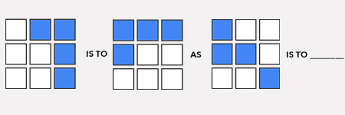

Which image completes it?

**1 / 1 point**



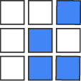



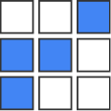



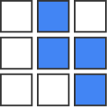



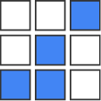

**Correct**

Since the pattern in the first image was rotated 90 degrees counter-clockwise, this image completes the statement.

**7.**

Question 7

The following series of codes are in a sequence from left to right. There is a repeating pattern that you will notice. Determine the pattern and decide which code should come next.

Fill in the blank: A1, B3, C5, D7, E9, F11, G13, _____

**1 / 1 point**



J15



H16



D17



H15

**Correct**

The patterns of this series are the letters listed alphabetically and the numbers increasing by two with each new set. Therefore, following that pattern, the next code would be H15.

**8.**

Question 8

The following series of codes are in a sequence from left to right. There is a repeating pattern that you will notice. Determine the pattern and decide which sequence of letters should come next.

Fill in the blank: A, AA, AAA, B, BA, BAA, BAAA, BB, BBA, BBAA, BBAAA, BBB, ________

**1 / 1 point**



BBAAA



BBBA



BBAA



BBBB

**Correct**

The pattern in this sequence follows the letter A. A is added until there are three As, which is when the letter B takes the place of the previous As, and the pattern continues. Therefore, BBBA is next in the series.

**9.**

Question 9

Now, identify patterns in a word problem using a data visualization. There are 12 chocolates in a box: eight have caramel filling, six have coconut filling, and two have both caramel and coconut filling. Choose the best image that describes this box of chocolates.

**1 / 1 point**



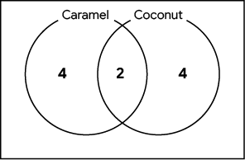



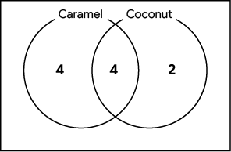



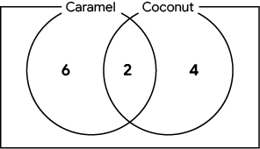



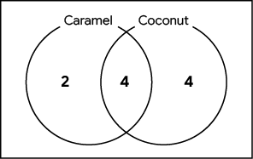

**Correct**

This diagram depicts six chocolates with caramel filling only, four chocolates with coconut filling only, two chocolates with both caramel and coconut filling, and the total number of chocolates is 12.

**10.**

Question 10

There are 10 children in a class and they have all brought sandwiches for lunch: five children have sandwiches with peanut butter, six children have sandwiches with jelly, and three children have sandwiches with both peanut butter and jelly.

Find out how many children have sandwiches with neither peanut butter nor jelly and choose the image that describes the situation best.

**1 / 1 point**



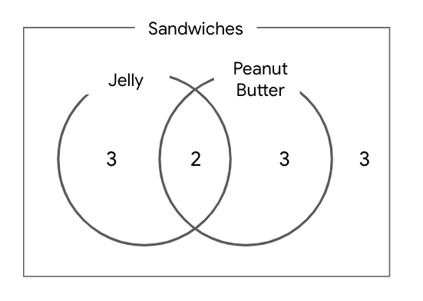



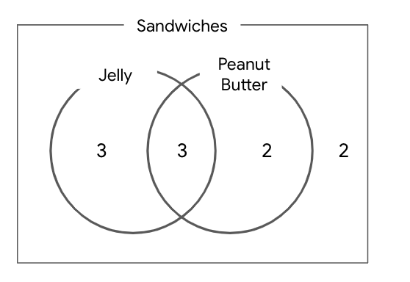



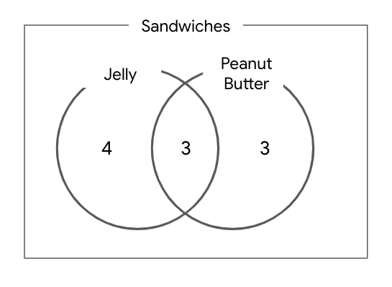



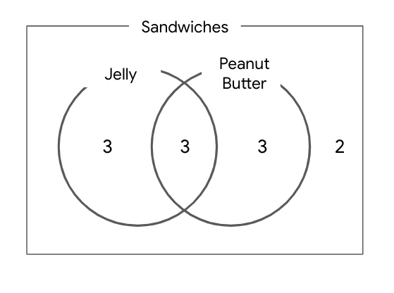

**Correct**

In this diagram, there are six sandwiches with jelly, five sandwiches with peanut butter, and three sandwiches with both. This means that there are (5 + 6 - 3 = 8 ) eight sandwiches with either peanut butter or jelly. There are a total of 10 children. Consider: 10 - 8 = 2. This means two children have neither peanut butter nor jelly in their sandwiches.

Description

The analytical skill that involves managing the processes and tools used in data analysis

Skill

Data strategy

Description

The analytical skill that has to do with how you group things into categories

Skill

Understanding context

Description

The analytical skill that involves how you organize information

Skill

Data design

Description

The analytical skill that involves breaking processes down into smaller steps and working with them in an orderly, logical way

Skill

A technical mindset

Description

The qualities and characteristics associated with solving problems using facts

Skill

Analytical skills

To execute a plan using detail-oriented thinking, what does a data analyst consider?



The big picture



The main idea



The specifics



The root cause

**Correct**

To execute a plan using detail-oriented thinking, a data analyst considers the specifics.

In the example problem of not having enough blueberries to make a pie, what root cause was revealed through the Five Whys process?



Mulberry bushes were damaged by a late frost



Blueberry bushes didn't have enough fruit



Birds ate the blueberries growing on bushes



Birds ate blueberries instead of mulberries

**Correct**

This was the answer to the fifth "why" question: why didn't the mulberry bushes produce any fruit?. The Five Whys process is used to reveal a root cause of a problem through the answer to the fifth question. Read how root causes in business settings have also been identified using the Five Whys process in an [article by Eric Ries](https://www.fastcompany.com/1669738/to-get-to-the-root-of-a-hard-problem-just-ask-why-five-times).

## Test your knowledge on analytical thinking

**Total points**4

### 1.

Question 1

What practice involves identifying, defining, and solving a problem by using data in an organized, step-by-step manner?

**1 / 1 point**



Context



Analytical thinking



Data design



Visualization

**Correct**

Analytical thinking involves identifying and defining a problem, then solving it by using data in an organized, step-by-step manner.

### 2.

Question 2

Which of the following are examples of data visualizations? Select all that apply.

**1 / 1 point**



Reports



Maps

**Correct**

Graphs, maps, and charts are used in data visualization.



Graphs

**Correct**

Graphs, maps, and charts are used in data visualization.



Charts

**Correct**

Graphs, maps, and charts are used in data visualization.

### 3.

Question 3

Gap analysis is used to examine and evaluate how a process currently works with the goal of getting to where you want to be in the future.

**1 / 1 point**



True



False

**Correct**

Gap analysis is used to examine and evaluate how a process currently works with the goal of getting to where you want to be in the future.

### 4.

Question 4

Which aspect of analytical thinking involves being able to identify a relationship between two or more pieces of data?

**1 / 1 point**



Data design



Visualization



Context



Correlation

**Correct**

Correlation involves being able to identify a relationship between two or more pieces of data. A correlation is like a relationship.